EDUGENIE-AI
Google Gemini Powered Learning Assistant

PROJECT DOCUMENTATION

AI-Powered Educational Assistant

Role | Name | Register No.
Team Leader | M. Nanjil | 25081371802112135
Team Member | S. Aarthi | 101
Team Member | V. Ajeetha | 103
Team Member | M. Anushiya | 107

Prepared for Project Submission

CERTIFICATE
This is to certify that the project entitled “EduGenie-AI – Google Gemini Powered Learning Assistant” has been documented as a team project by the students listed in this document. The project demonstrates an AI-assisted educational web application with modules for question answering, concept explanation, quiz generation, text summarization, and learning-path recommendations.
Team Leader: M. Nanjil
Team Members: S. Aarthi, V. Ajeetha, M. Anushiya

DECLARATION
We declare that the EduGenie-AI project documentation presented here describes the implementation, interface, modules, REST API endpoints, testing evidence, and observed application screens of our project.

ACKNOWLEDGEMENT
We express our sincere gratitude to everyone who supported the development and documentation of EduGenie-AI. We also acknowledge the use of modern generative-AI technologies and web-development frameworks that enabled the project to provide interactive educational assistance.

ABSTRACT
EduGenie-AI is a Google Gemini powered learning assistant designed to support students through a single web-based interface.
The application provides educational assistance through five major functions: Question and Answer, Concept Explanation, Quiz Generation,
Text Summarization, and Learning Path Recommendation. A FastAPI backend exposes RESTful endpoints for these functions, while a web frontend
provides a simple task-selection interface. The project integrates generative AI to transform user questions, topics, and study material into
interactive learning support. The documented screenshots demonstrate the project structure, running application, module interfaces, and Swagger/OpenAPI REST API documentation.

1. INTRODUCTION
Students often need quick explanations, concise notes, practice questions, and guidance on what to learn next. Traditional study resources
may require switching between multiple tools. EduGenie-AI brings several learning-support activities into one application. The user selects a
task, provides a topic or text, and submits it through the interface. The backend processes the request and connects the relevant module to the
generative-AI service.

2. PROBLEM STATEMENT
Learners may spend considerable time searching for explanations, creating practice questions, shortening study notes, and deciding on a
learning sequence. A unified AI-assisted educational application can reduce this fragmentation by providing these functions through one interface.

3. OBJECTIVES
• Provide an interactive AI-powered educational assistant.
• Answer student questions using generative AI.
• Explain concepts in a learner-friendly manner.
• Generate quizzes from a selected topic.
• Summarize educational text into concise study material.
• Recommend a learning path based on a topic and learning level.
• Expose each major function through a RESTful API.
• Provide a simple web interface for interacting with the backend.

4. PROPOSED SYSTEM
The proposed system combines a web frontend, FastAPI backend, module-level application logic, and a Gemini-based generative-AI service.
The frontend collects the user's task and input. The backend validates the request and routes it to the corresponding module. The module prepares
the required prompt and obtains an AI-generated response through the Gemini service. REST endpoints make the functions independently accessible
for testing and integration.

5. TECHNOLOGIES USED
• Python
• FastAPI
• Google Gemini / Generative AI service
• HTML5
• CSS3
• REST API
• OpenAPI / Swagger UI
• Pydantic-based request validation
• VS Code for development
• Python virtual environment (.venv)

6. SYSTEM MODULES
6.1 Question and Answer (Q&A): Accepts a learner's question and produces an educational answer.
6.2 Concept Explanation: Accepts a concept such as “Machine Learning” and generates a clear explanation.
6.3 Quiz Generation: Accepts a topic such as “Artificial Intelligence” and generates quiz-oriented learning content.
6.4 Text Summarization: Accepts study material or notes and produces a concise summary.
6.5 Learning Path Recommendation: Accepts a topic and learning level, such as Beginner, and creates a structured learning path.

7. REST API ENDPOINTS
The documented Swagger interface shows the following REST endpoints:
GET / – Home endpoint
GET /health – Health/status endpoint
POST /qa – Question and Answer
POST /explain – Concept explanation
POST /quiz – Quiz generation
POST /summarize – Text summarization
POST /learn/recommendations – Learning path recommendation
The API documentation also exposes request schemas including QARequest, QuizRequest, TextRequest, and LearningPathRequest.

8. SYSTEM WORKFLOW
1. The user opens the EduGenie-AI web application.
2. The user selects one of the available educational tasks.
3. The user enters a question, concept, topic, or text.
4. The frontend sends the request to the corresponding FastAPI endpoint.
5. The backend validates the request and routes it to the appropriate module.
6. The module prepares the AI prompt and calls the Gemini service.
7. The generated educational response is returned to the application and presented to the user.

9. IMPLEMENTATION
The project is organized as a Python/FastAPI application with configuration, AI-client integration, separate educational modules,
frontend templates, static styling, and automated test files. The project screenshot shows configuration files, Gemini client code, module files,
the FastAPI entry point, requirements, frontend assets, and tests in a single project workspace.

10. TESTING
The application was checked through its running web interface and the Swagger/OpenAPI documentation. The screenshots provide evidence that
the application loads, reports a connected backend, exposes the major learning tasks, and publishes the REST endpoints. The project also contains
a tests/test_modules.py file for module-level testing.

11. RESULTS
The documented execution screens show the EduGenie-AI interface operating with the backend connected. The five educational functions are
available from the task selector, and the Swagger screen exposes the corresponding REST API endpoints. These screens provide visual evidence
of the implemented user interface and API structure.

12. ADVANTAGES
• Unified educational assistance in one interface.
• Multiple learning functions in a single application.
• RESTful architecture supports modular integration.
• Generative AI can produce flexible educational content.
• Simple web interface suitable for student interaction.
• Swagger/OpenAPI documentation supports API testing and development.

13. LIMITATIONS
• Generated content depends on the underlying AI service and prompt quality.
• An internet connection and valid AI API configuration may be required for live generation.
• AI-generated responses should be reviewed by learners or educators when accuracy is critical.
• The documented interface is a lightweight application and can be extended with authentication, persistence, analytics, and richer learning management features.

14. FUTURE ENHANCEMENTS
Future versions can include user accounts, saved learning history, progress tracking, adaptive recommendations, multilingual learning,
persistent quiz scores, teacher dashboards, document upload, richer analytics, and additional AI-powered study tools.

15. CONCLUSION
EduGenie-AI demonstrates how generative AI can be integrated into an educational web application to support common learning activities.
The project brings Q&A, concept explanation, quiz generation, summarization, and learning-path recommendation into one interface and exposes
these functions through RESTful FastAPI endpoints. The screenshots included in this document provide visual evidence of the project structure,
application interface, module inputs, and API documentation.

16. TEAM DETAILS
The EduGenie-AI project team consists of the following members:

Role | Name | Register No.
Team Leader | M. Nanjil | 25081371802112135
Team Member | S. Aarthi | 101
Team Member | V. Ajeetha | 103
Team Member | M. Anushiya | 107

17. SCREENSHOTS / OUTPUT EVIDENCE
The following screenshots document the implemented project structure, application execution, user interface, individual learning modules, and REST API documentation.
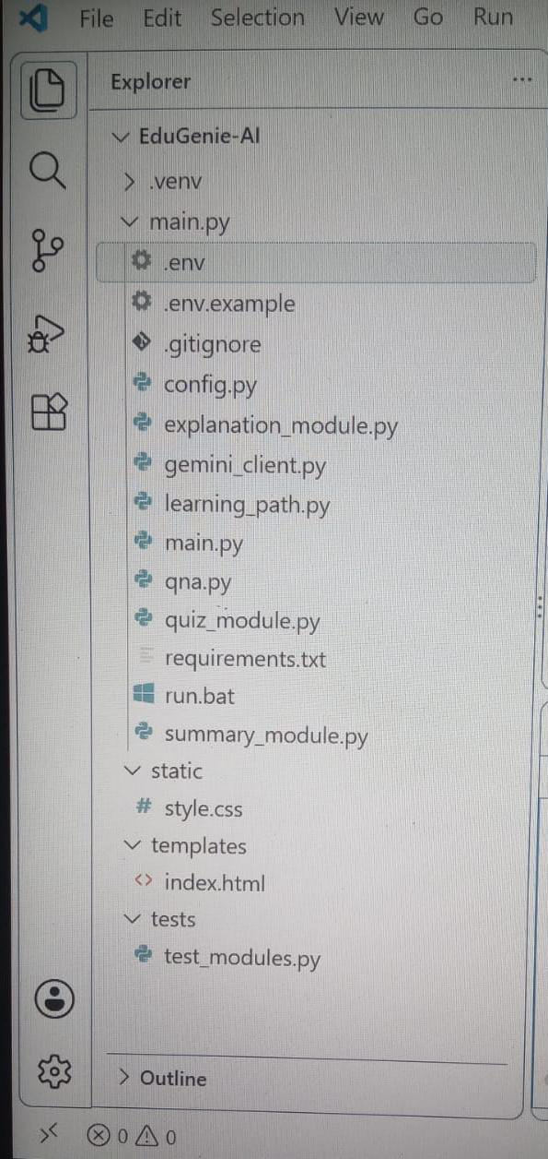
Figure 1: EduGenie-AI Project Structure

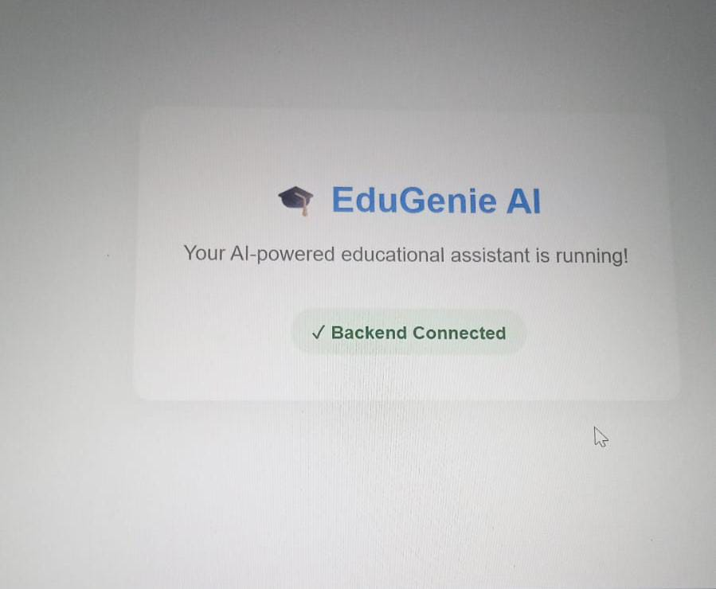
Figure 2: EduGenie AI Application Running – Backend Connected

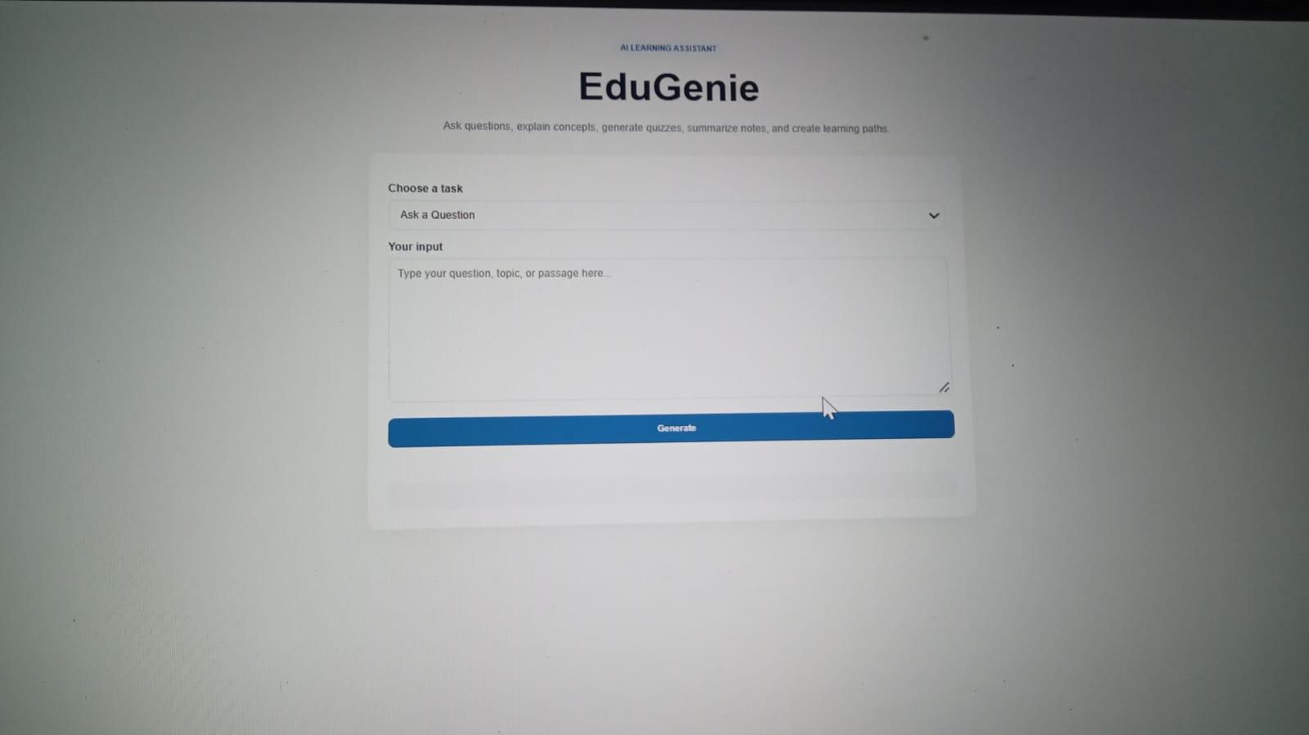
Figure 3: EduGenie AI Main User Interface

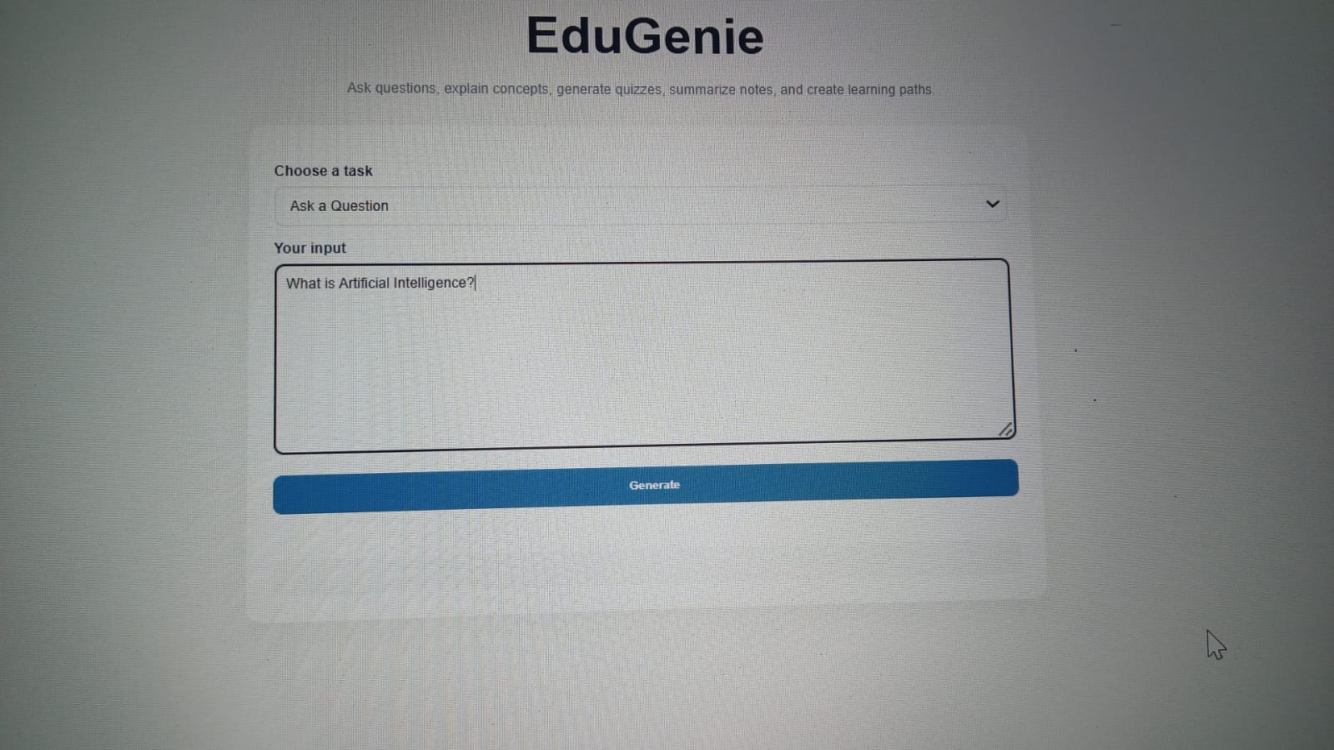
Figure 4: Question and Answer Module

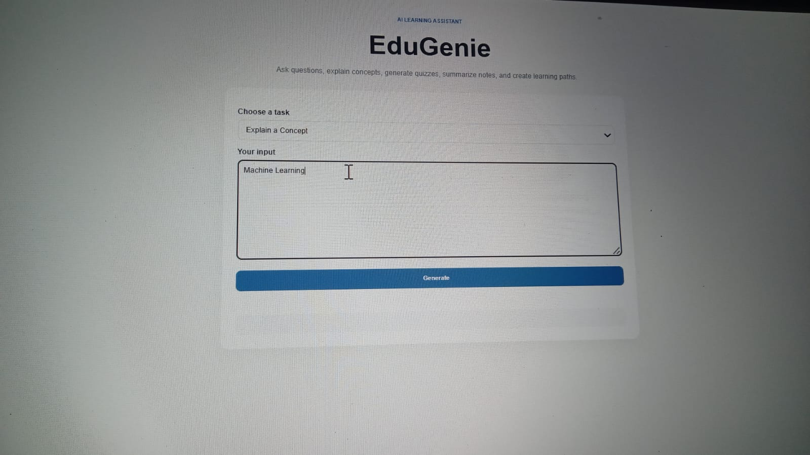
Figure 5: Concept Explanation Module

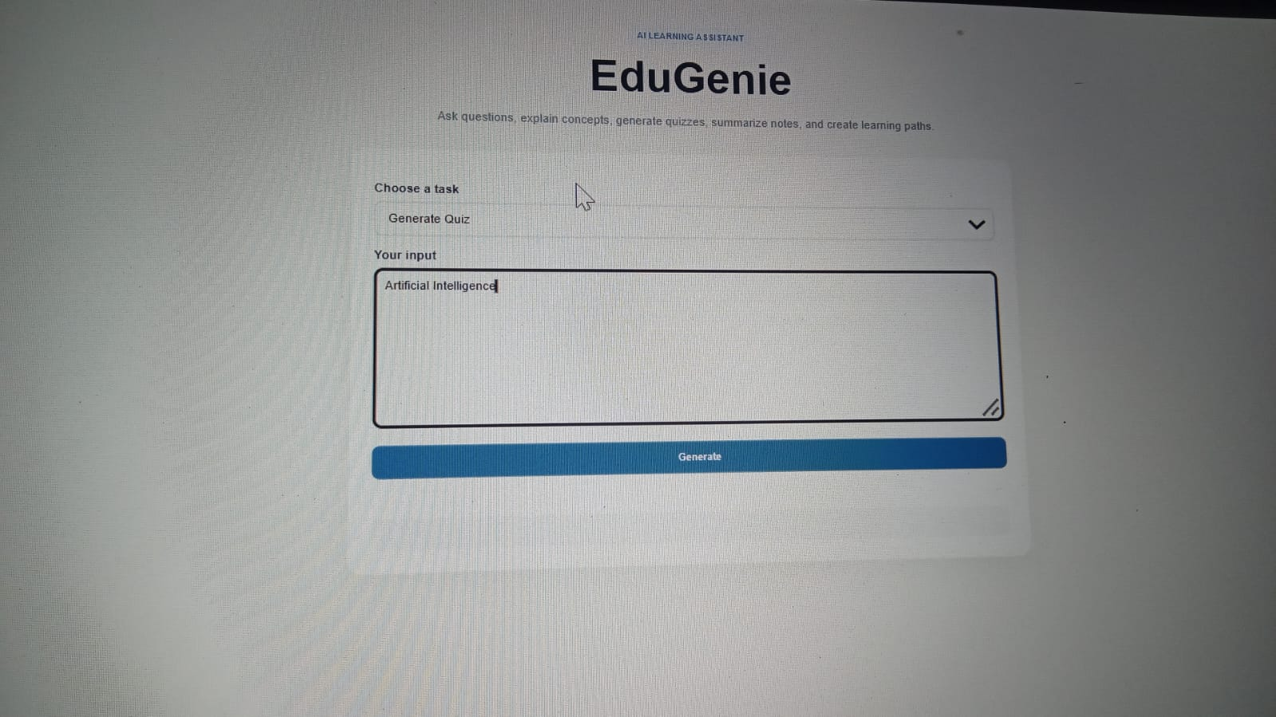
Figure 6: Quiz Generation Module

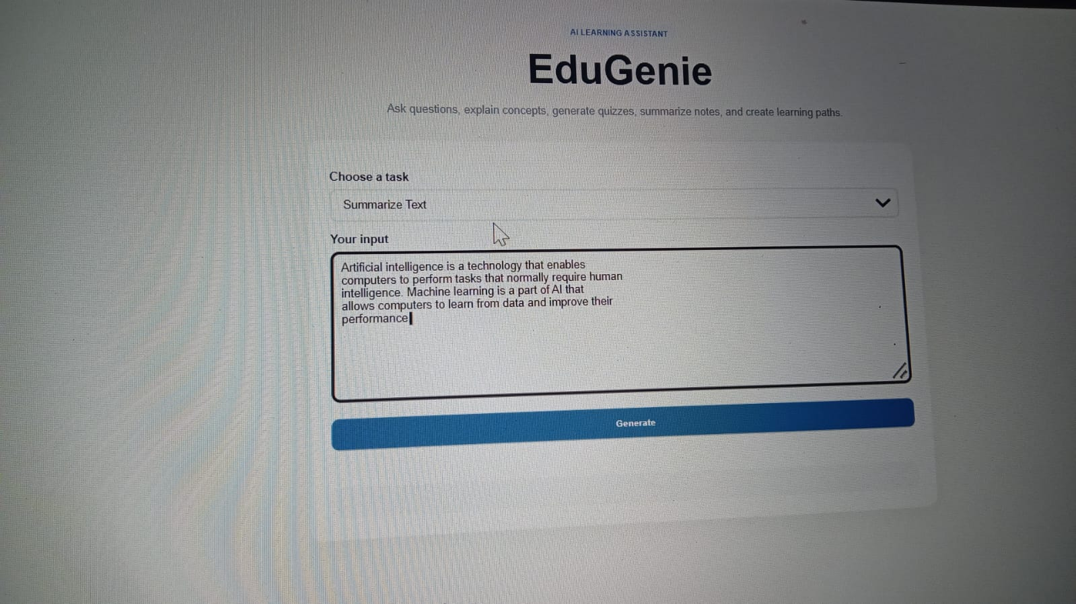
Figure 7: Text Summarization Module

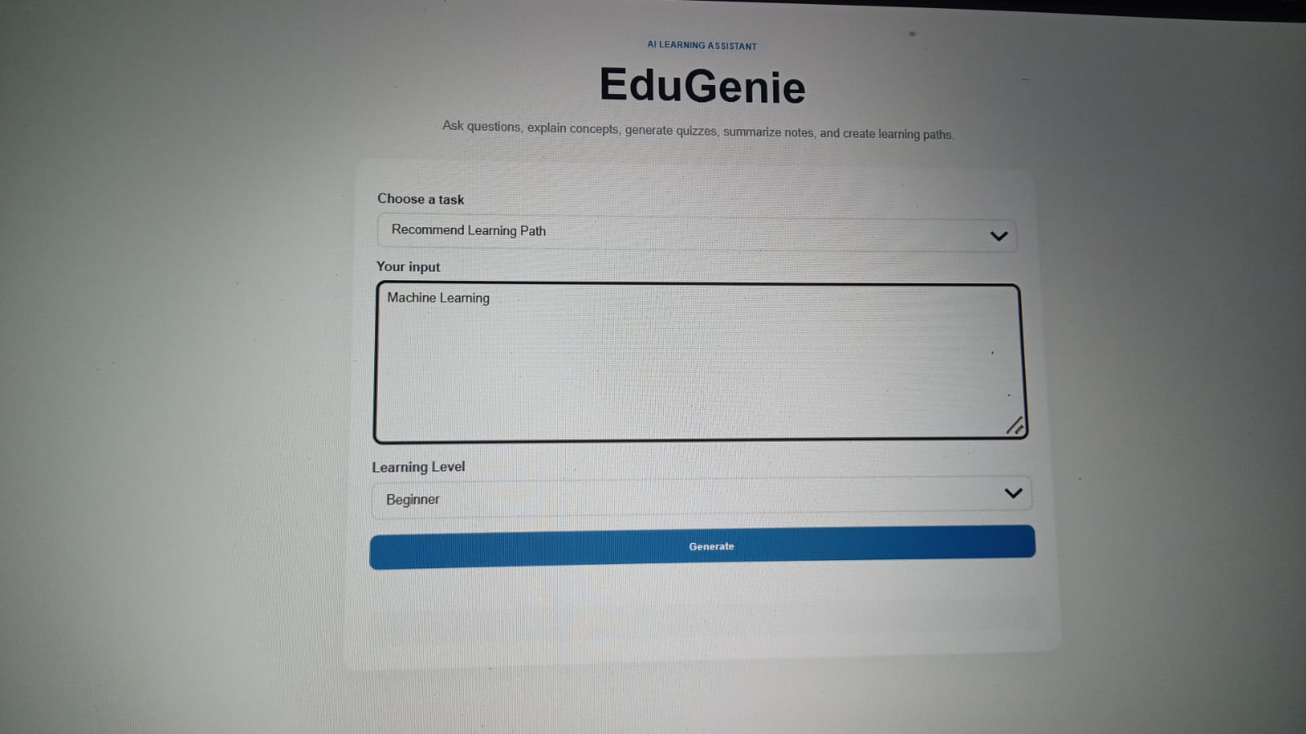
Figure 8: Learning Path Recommendation Module

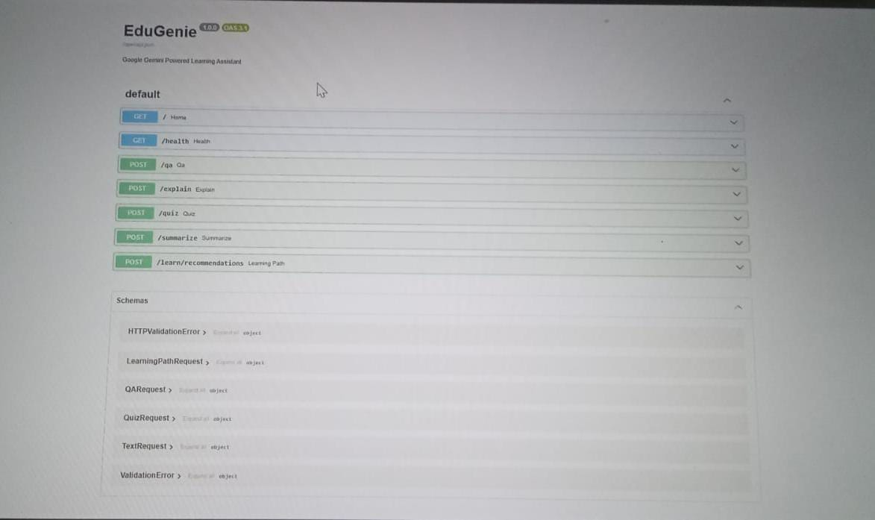
Figure 9: REST API Endpoints and Swagger Documentation

18. REFERENCES
FastAPI documentation and OpenAPI/Swagger concepts.
Python documentation and virtual-environment usage.
Google Gemini / Generative AI developer documentation.
HTML and CSS web-development standards.

